- PRESS RELEASE -

Breaking the Ice
A brilliant new version of the children’s fortune-teller

Würzburg, Germany, 18.08.2018 - Like many a start-up, jewellery designer Rowena Murray began with a single sheet of paper. Unusually however, this sheet of paper became her very first product. Inspired by the children’s fortune-teller, with a few simple folds it transforms into a three dimensional diamond. Named ‘Brilliant!’, the facets then break open to reveal eight topics explaining the science and study of diamonds in bitesize form.

‘When I first decided to create a booklet about diamonds,’ says Rowena, ‘I wanted to represent the subject in its fullest sense and make the facets of its character tangible somehow. Learning is often called ‘discovering’, whilst to understand something is to ‘grasp’ it. And so with this in mind, I felt the fortune-teller format fitted perfectly.’

Designed especially for children, ‘Brilliant!’ was also shaped to parent’s and retailer’s needs:
- Brilliant for Retailers -> A unique product with a compact size and high turnover
- Brilliant for Parents -> An eco-friendly gift that doesn’t compromise on design
- Brilliant for children -> A learning experience that doesn’t compromise on fun

Retailing at €4.75, ‘Brilliant!’ is a small package with lots to it. The featured artwork by London designer, Rory Farrell, references the original colour sequence of the game, whilst each topic is explained via text and illustrations. Finally, the entire package is printed in the UK on recycled paper using vegetable based inks.

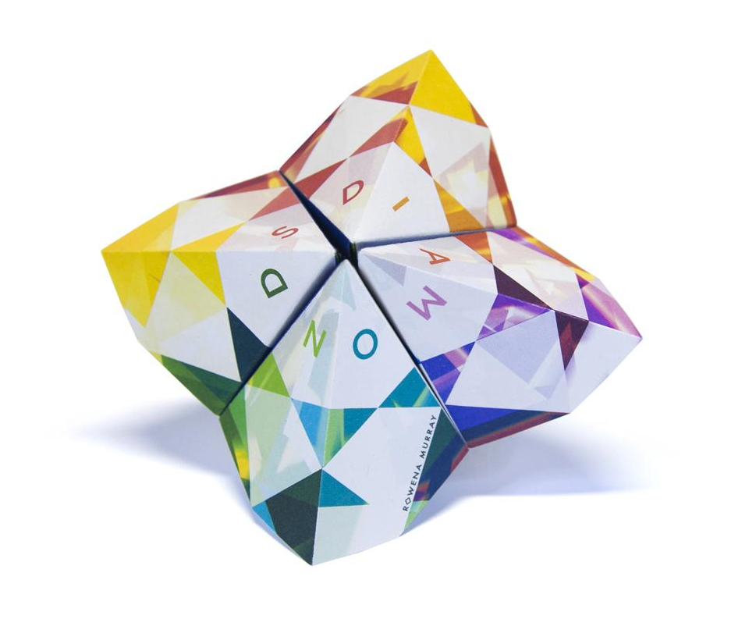
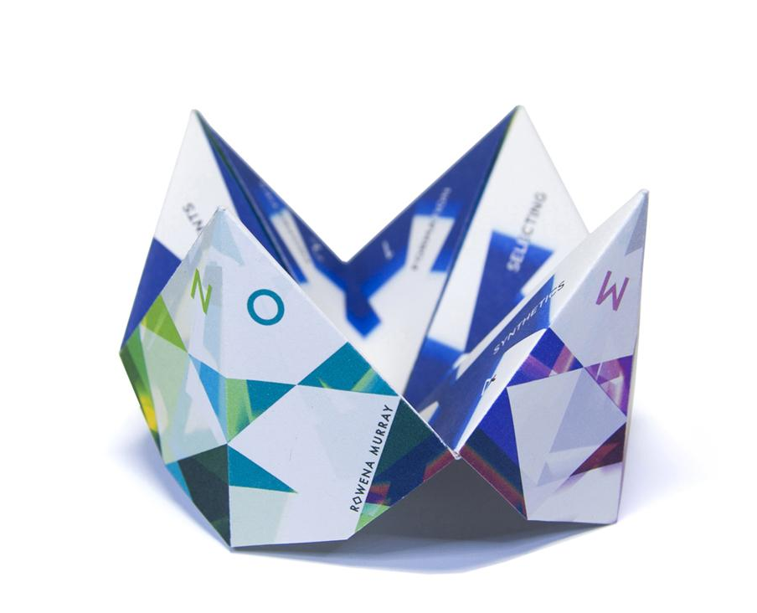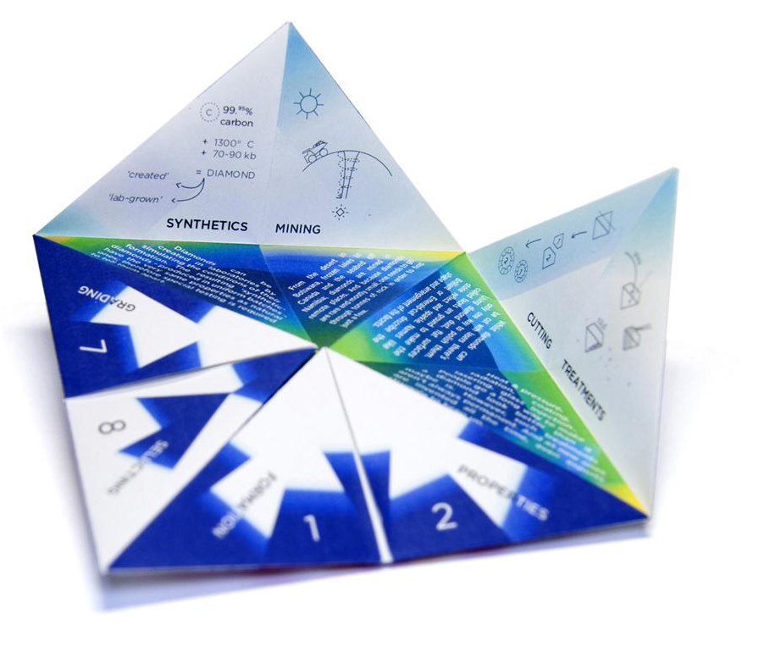

Discover more online at - www.rowenamurray.de/products/brillant

About Rowena Murray
Rowena Murray is a British jewellery designer and graduate of the Royal College of Art, with a diploma from the Gemological Institute of America. During time spent in Milan, London and Switzerland, she designed collections for brands including Van Cleef & Arpels, Accessorize and Audemars Piguet, alongside teaching work.

Now based in Germany, in 2017 she established a design studio specialised in developing jewellery and objects for children and young families. Upcoming projects include an ‘animated’ jewellery collection and a series of reimagined designs from her archive.

Contact
For more information, visit online at: www.rowenamurray.de
To contact Rowena Murray by email: press@rowenamurray.de / or telephone: +49 (0)176 2295 9403

- ### -

